Lahore Garrison University
DHA Phase 6 Lahore



Student Name | Faiqa Altaf
Student Roll No | Fa23/BSCS/155
Section | D
Subject | Web Technology
Instructor Name | Mr. Muhammad Yousaf

Lab 5: Forms & Multimedia
Step 1: Create an XML File:
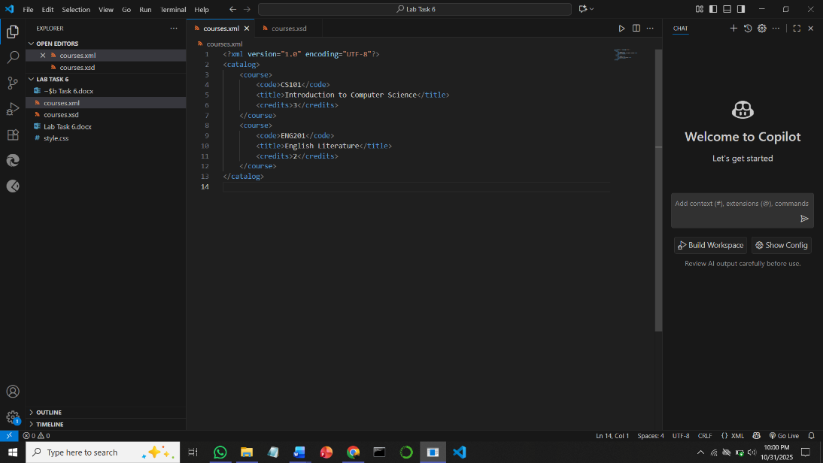

Step 2: Create an XSD File to Validate XML
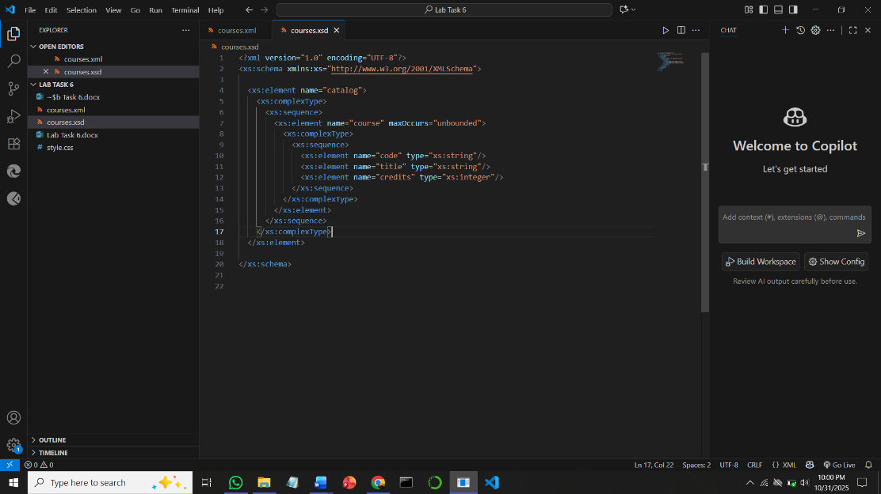

Step 3: Validate XML Against XSD
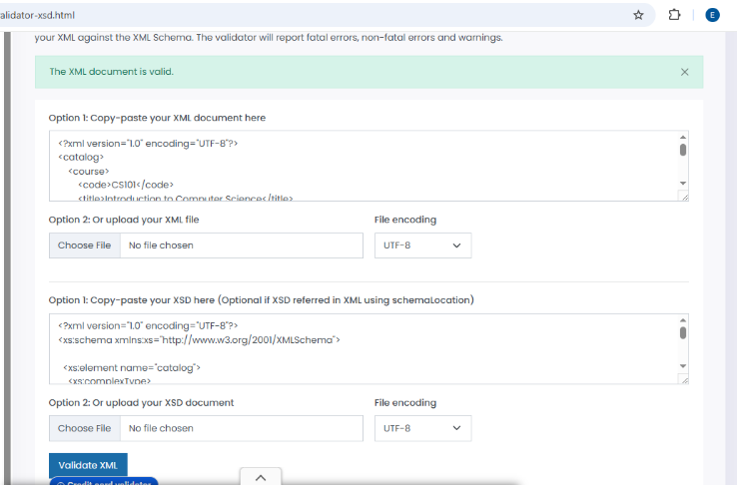

Converted XHTML:
<?xml version="1.0" encoding="UTF-8"?>
<!DOCTYPE html PUBLIC "-//W3C//DTD XHTML 1.0 Strict//EN"
"http://www.w3.org/TR/xhtml1/DTD/xhtml1-strict.dtd">
<html xmlns="http://www.w3.org/1999/xhtml" xml:lang="en" lang="en">
<head>
<meta http-equiv="Content-Type" content="application/xhtml+xml; charset=UTF-8" />
<title>Sample Page</title>
</head>
<body>
<h1>Welcome</h1>
<p>This is a sample page.</p>
</body>
</html>
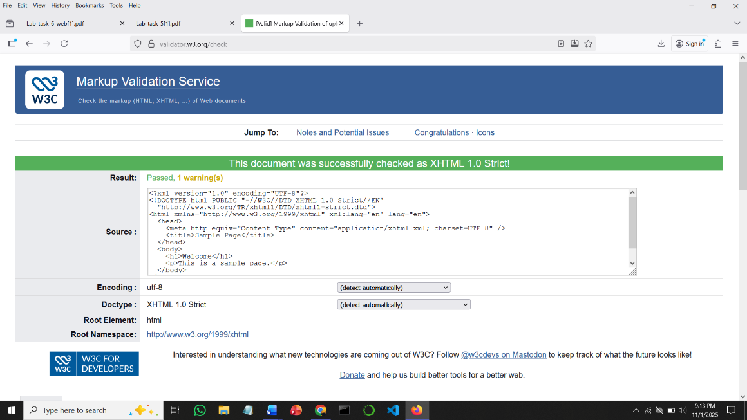

Conclusion:
XML serves as a versatile framework for structuring and storing data in a clear, human-readable format. XSD (XML Schema Definition) provides a robust mechanism to define the structure, data types, and validation rules for XML documents. By integrating XML with XSD, organizations can ensure data consistency, integrity, and interoperability across systems. This combination enhances data validation, minimizes structural errors, and supports efficient information management.

